# Name: Abdurrahman Qureshi

# Roll no: 210451

## Practical no 17: -

## Aim: Execute DCL Commands

* Practical Related Questions

1. Create user jyoti identified by mitpoly;

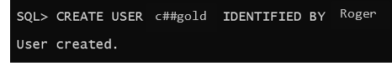

1. Grant create table ,create view to jyoti;

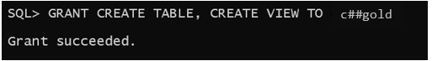

1. Grant select,insert,update on Emp to jyoti;

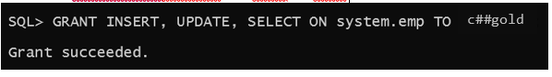

1. Grant select,update(deptno,empno) on Dept to jyoti;



1. Alter user jyoti identified by mit;

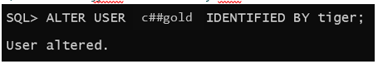

1. Revoke create table,create views from jyoti;

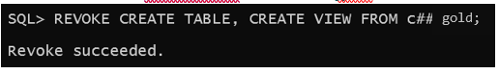

1. Revoke select,insert,update on Emp from jyoti;



1. Create role emp_pvr;

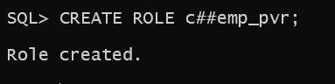

1. Grant create table,create views to emp_pvr;

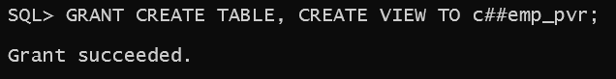

1. Grant emp_pvr to jyoti,john; 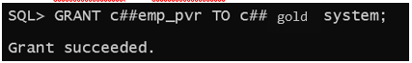

* Exercise

1. Create user john and implement the following commands on table Emp and Dept.

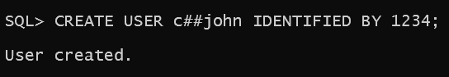

1. Write a query to grant select,insert,delete privileges on Emp and Dept table.

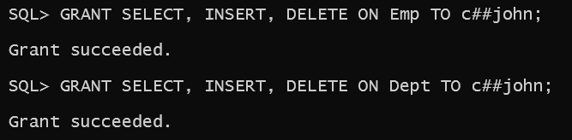

1. Write a query to grant update privileges on columns of empno and salary nts table.

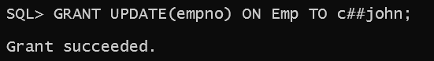

1. Write a query to revoke all above privileges from Emp and Dept table.

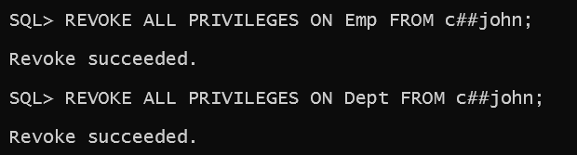

1. Write query to create role dept_pvr;

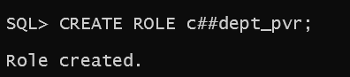

1. Write query to assign system privileges-create table,create view to role dept_pvr;

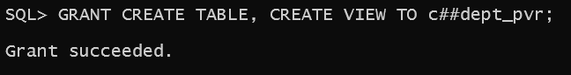

1. Write query to assign above system privileges to users jyoti and john.

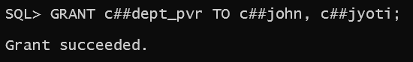

1. Write query to assign object privileges-select, insert, delete to role dept_pvr;

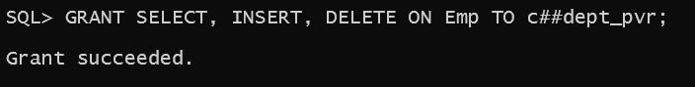

1. Write query to assign above object privileges to users jyoti and john.

